

**Uttara University**

Assignment-02

**Course Title : INTERNET PROGRAMMING**

**Course Code : CSEC422**

**Department : Computer Science and Engineering**

**Submitted To: Submitted by:**

**Md. Harun-Ar-Rashid Monsur Fuad Khan**

**Lecturer, ID: 2221081106**

**Department of CSE, Batch : 56 (B)**

**Uttara University Semester: Spring-2025**

**Submission Date: 16-02-2025**

**Title: Result Average Calculation Web-Page Using Bootstrap and JavaScript**

**Working Procedure:**

1. **Introduction**:
   * The objective of this lab is to create a web-based application that calculates the average score of three subjects. The user inputs the scores for each subject, and the application computes the average and displays the result.
2. **Design & Layout**:
   * The web page is designed using HTML for structure, CSS for styling, and JavaScript for functionality.
   * The page contains:
     + Three input fields for entering scores for each subject.
     + A result field that displays the average score.
     + A "Calculate AVG" button that triggers the calculation.
   * The UI is enhanced using **Bootstrap 5** for responsiveness and better design, including gradients and custom buttons.
3. **Input Fields**:
   * The application provides three input fields where the user enters scores for Subject 1, Subject 2, and Subject 3.
   * Each input field accepts numerical values only.
4. **Calculation Process**:
   * When the user clicks the "Calculate AVG" button:
     + The values entered in the input fields are retrieved by JavaScript.
     + These values are converted into floating-point numbers using the parseFloat() function.
     + The application checks if the inputs are valid (ensuring they are numbers) using isNaN().
     + If valid, the average is calculated by summing the three scores and dividing by 3.
     + The result is displayed in the "Result" input field with two decimal places using toFixed(2).
5. **Error Handling**:
   * If any of the input fields contain invalid or non-numeric data, the application displays an error message prompting the user to enter valid numbers.

**Source Code:**

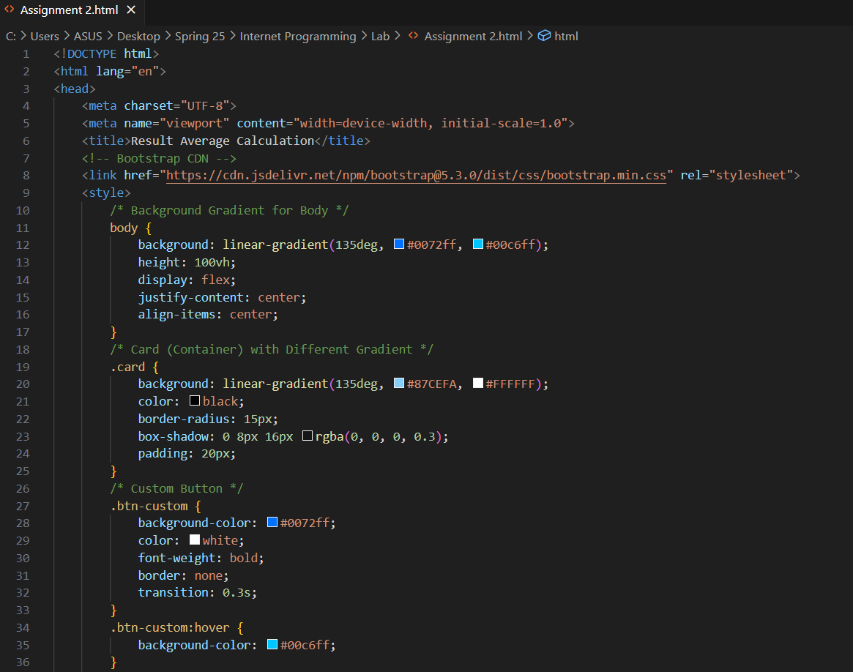

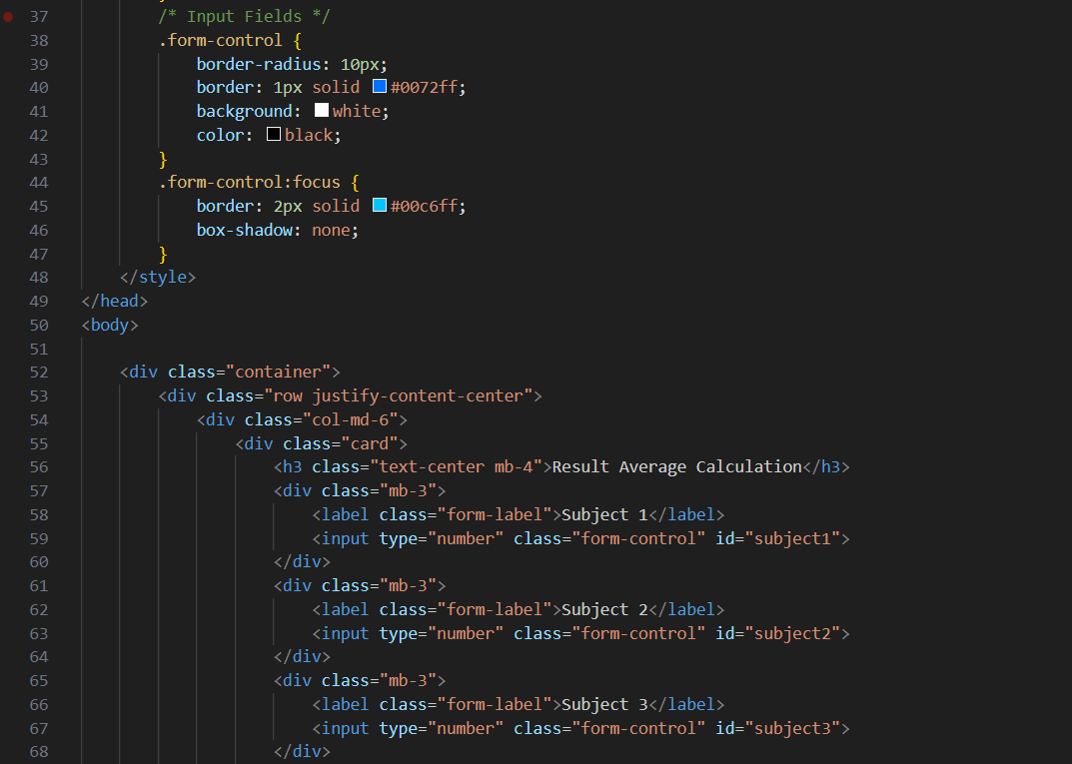

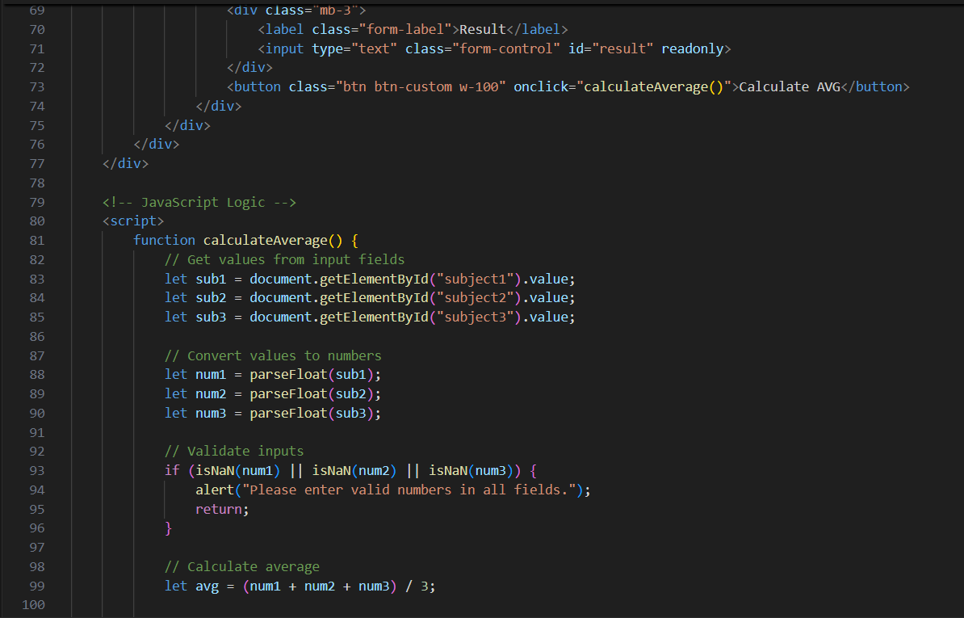

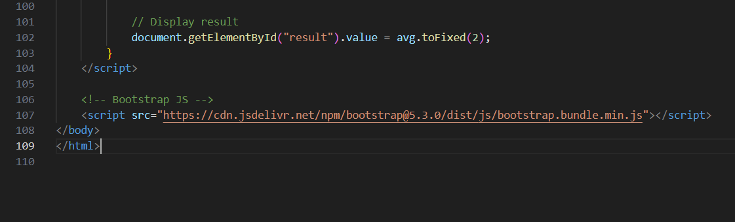

**Output:**

